Reimagining Community Safety & Policing Survey

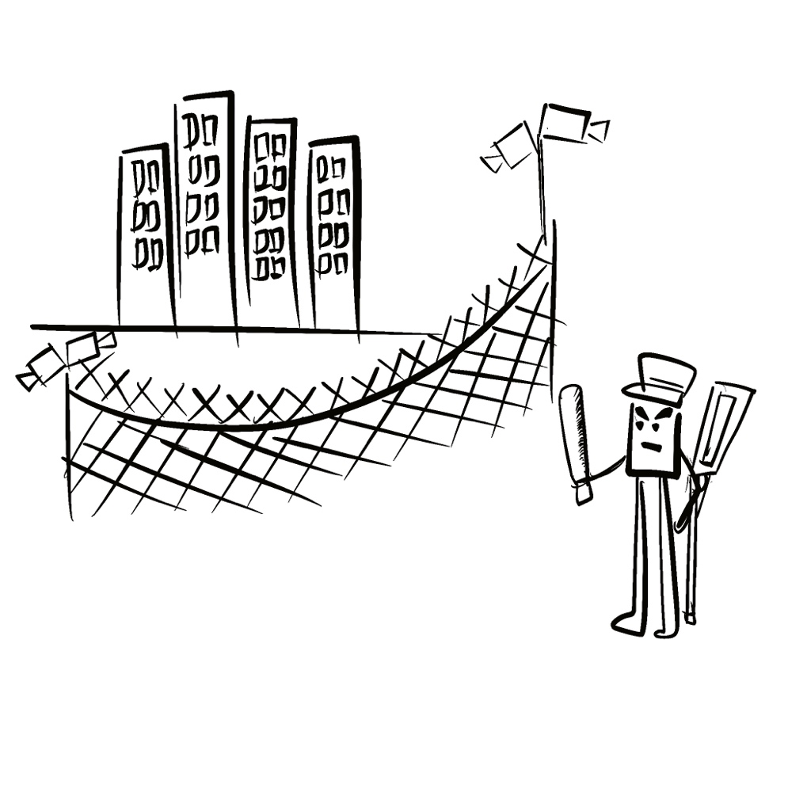
Surveillance Cameras
Community
Police
Survey Organiser: The Access to Justice Knowledge Hub for Fair Participation
Easy Read by Michele Chung and Consulted with Chosen Power

Who is “The Access to Justice Knowledge Hub for Fair Participation”?
 | The organiser of this survey is “The Access to Justice Knowledge Hub for Fair Participation”. (The Hub)
 | The Hub is a group of international disability rights and criminal justice reform organisations and individuals.
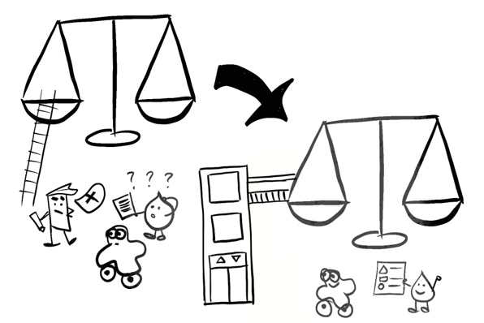 | The Hub seeks to transform justice systems so that persons with disabilities can participate equally and fairly.
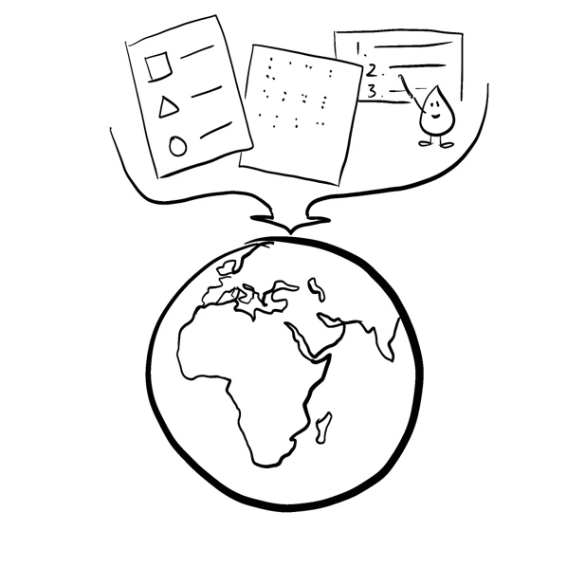 | The Hub will create an easy-to-use discussion tool for people from around the world who are concerned about safety and policing.

What does this Survey do?
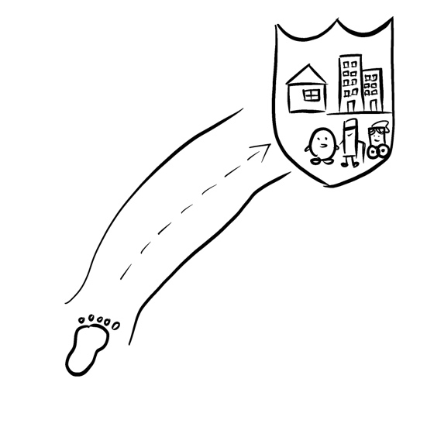 | This survey is the first step to creating the discussion tool.
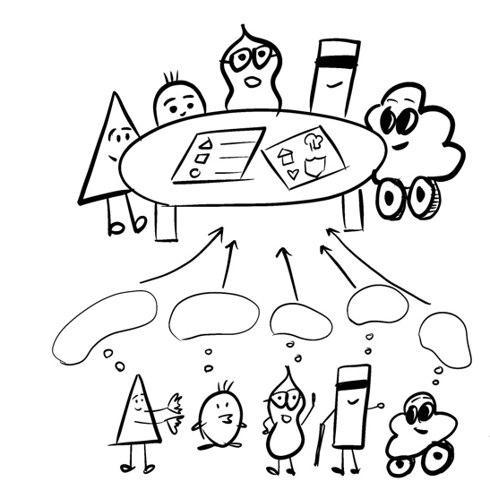 | This survey wants to gather ideas from people with disabilities as a foundation of how we reimagine community safety.
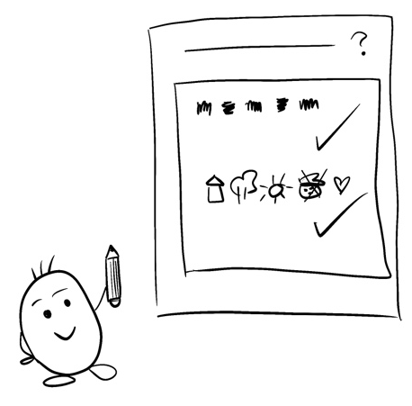 | This survey uses open-ended questions so you can freely express yourself. Please try to be as detail as possible.
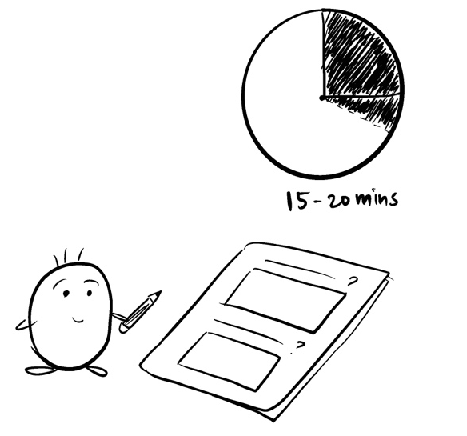 | This survey will take around 15 – 20 minutes to fill out.
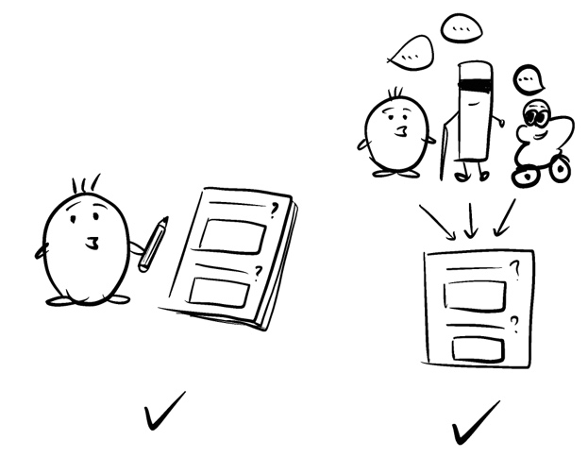 | You can:  - fill out on your own, or  - have one person fill out after collecting responses from a group.
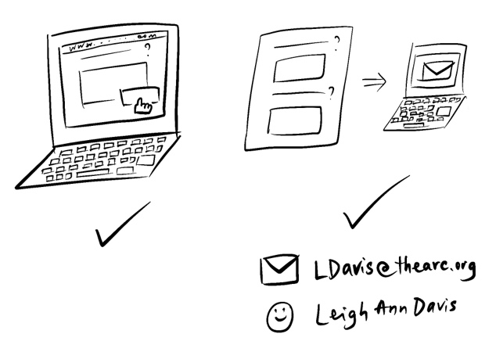 | You can:  - fill out the survey on this website directly, or  - use the Word document survey we emailed you  Please email your completed survey to Leigh Ann Davis at LDavis@thearc.org

The Survey
- Please think about the country that you live in. How might your freedom be taken away? You can also tell us about things that might happen to other people.
You can tell us about things like:
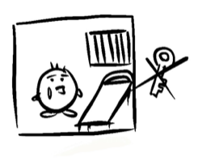  Being stopped from leaving your home by family or someone you live with. | 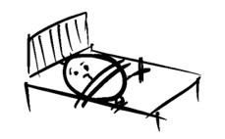  Being put in an institution, care home, camp or hospital and not allowed to leave.
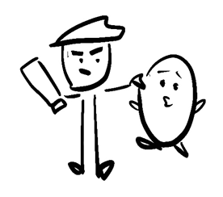  Being stopped and arrested by the police. | 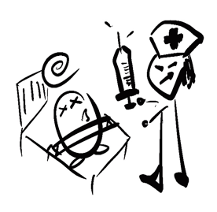  Being hurt by people who say they are there to help – for example, being drugged or put in restraints
Being hurt by someone you know (or someone you don’t know) –
for example, being hit by someone or someone forcing you to do something sexual.
Something else?
Please tell us what you think:

The Survey
- What do you think helps to keep people safe and free?
You might want to tell us about:
Being known by your neighbors and other people in your community and feeling like you belong. | 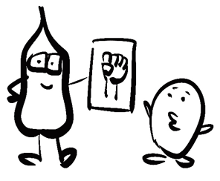  Knowing your rights and the laws that help protect your rights.
Having family, friends, peers, or others who help you get what you want (advocates). | Working together in a community to make life better for everyone.
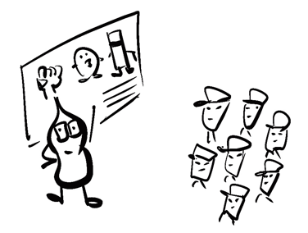
Training police officers about how to work with people with disabilities.
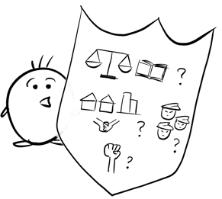
Something else?
Please tell us what you think:

The Survey
- a) Do you think it is possible for everyone to be safe and free, all the time?
If someone is hurting you, do you think that person should have their freedom taken away or limited?
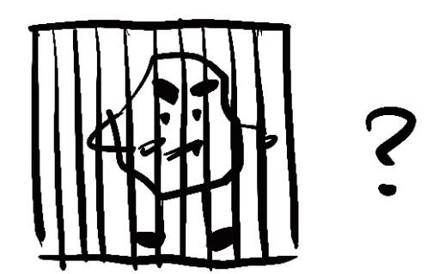
For example, should they be locked up in prison,
or should the person who hurt you no longer be able to be near you?
Please tell us what you think:

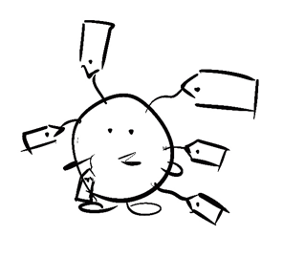
b) As a person with disability (who may also face discrimination in other ways as a minority, a woman or person who is LGBTQ)

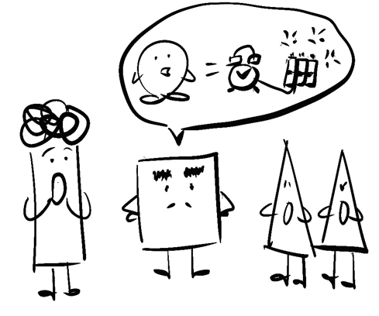
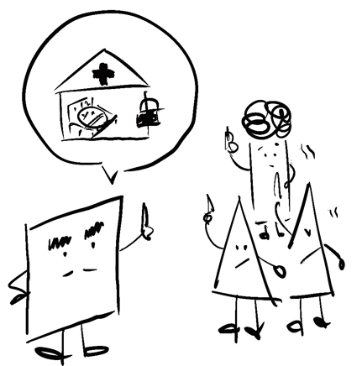
Do you think other people have used this as an excuse to take away your freedom? How does it make you feel when people say that because you are in the community, it makes them feel like they are in danger or less safe?

Please tell us what you think:

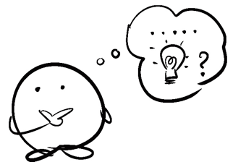
What are some of the examples of this happening? What should happen instead?
Please tell us what you think:

The Survey
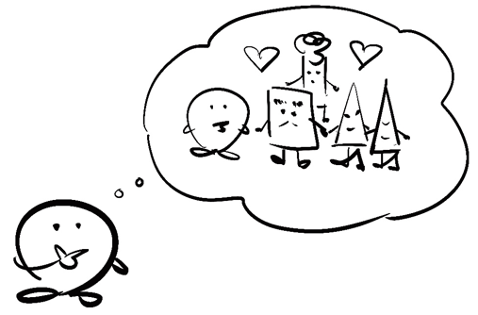
- What do you think helps people understand each other better and get along?
We want to know about things like:
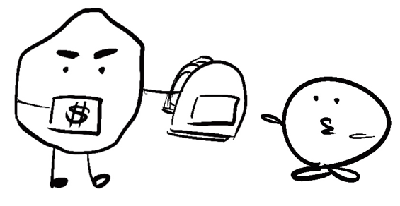
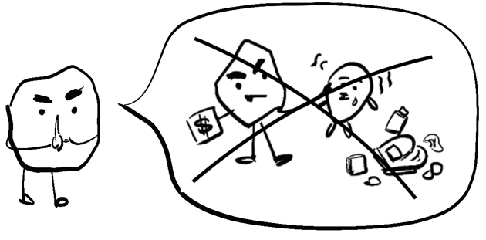
When a person who did something wrong admits it and tries to make things right with the person they hurt (this is sometimes called restorative justice).

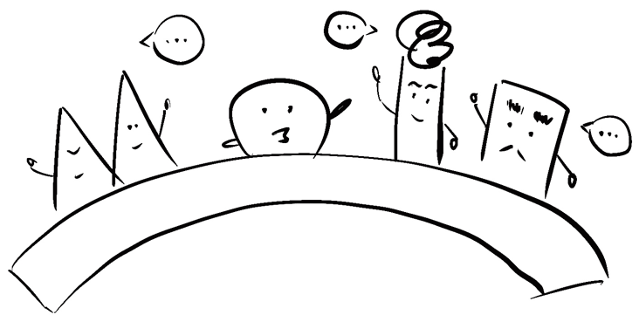
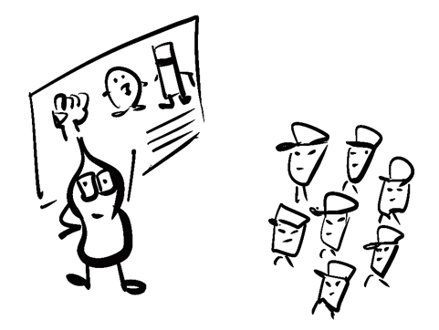
Training or meetings that help people understand each other’s differences and learn about biases people have toward other people they don’t know well.

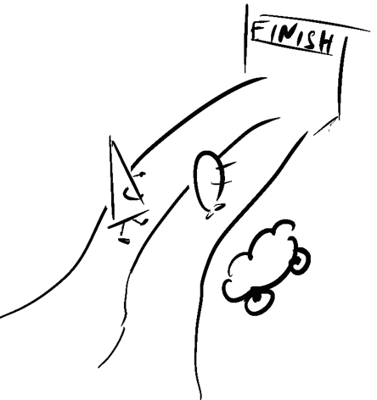
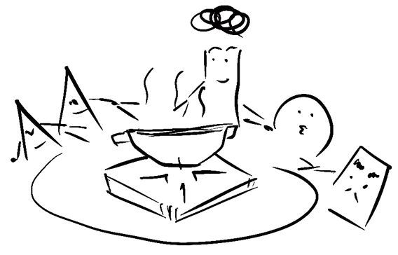
Other programs or practices that help people live in community together and get along (please provide some examples)

Please tell us what you think:

The Survey
- Is there anything else you want to tell us?

Please let us know here:

- Please tell us about yourself:
Name
Organization
State/Province
Country
Email Address
Phone Number
- Are you a disabled person or person with a disability?
Please feel free to answer yes, no and/or explain how you identify.
Please express yourself here:

- Are you filling out this survey as an individual responder or are you filling this out for another person or group of people? Check (ü) one response below:
I am responding for myself only.
I am responding for another person.
I am responding for a group of people
Other (please specify)

- Can you provide the names of DPOs, persons with disabilities, or others who might be interested in filling out the survey? If so, please provide contact information below, including name of person or organization and email address.
Name and Organization
Email Address

- Do you think this survey is accessible to our target audience of DPOs and persons with disabilities? Check (ü) one response below:

I believe the survey is accessible and will work for the target audience.
I believe the survey is somewhat accessible and will work for some, but not all, of the target audience.
I believe the survey is mostly accessible for the target audience.
How do you suggest we increase the overall accessibility for the target audience?
Please tell us your suggestions here:

- May we follow up with you directly for more information about your responses? Check (ü) one response below:
Yes
please provide your contact information
No

The End

